General routine
Discharge and filling of transmission oil of DCT
 | Discharge
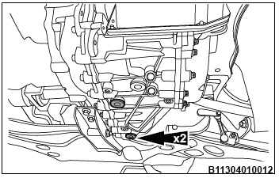 | Warning: oil temperature of transmission is relatively high after long time operation, which may lead to burns. So the vehicle is recommended to be at normal temperature and static status during discharge of transmission.  - Jack up and support vehicle.  Reference: related contents of 100-02 Towing and Jacking.  2. Remove bottom guard of engine.  Reference: related contents of 500-04 Exterior Trim Panel and Trimming.  ∠3. Remove oil drain plug at the bottom of transmission to drain transmission oil.  Torque: 60±3Nm  Note: proper vessel shall be placed underneath transmission during removal of oil drain plug.
∠4. Tighten oil drain plug of transmission.
Torque: 60±3Nm
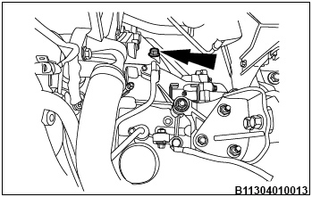 | 5. Lower the vehicle and remove air filter assembly.  Reference: related contents of 300-08 Intake Distribution and filtering.  ∠6. Remove oil filler plug of transmission.  Torque: 60±3Nm
7. Fill Pentosin FFL-2 gear oil with proper tools.
Note: fill 6L.
∠8. Install oil filler plug and oil filler plug gasket, and jack up the vehicle until wheels are approximately 20cm above ground;
Torque: 60±3Nm
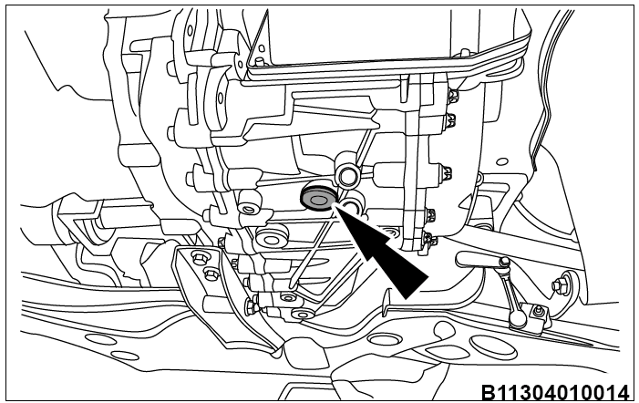 | 9. Shift to P gear, start vehicle and keep it at idling status;  10. Press brake pedal, and shift gears by following sequence: shift from R to N twice, and shift from N to D twice (brake pedal shall be pressed all the time during shifting process). Shift to N gear at last;  11. Press brake pedal, shift to R gear, release the pedal and let the wheels run for around 10s. Gently press brake until wheels stop running, and then shift to N gear. Repeat this operation once;  12. Press brake pedal, shift to D gear, release the pedal and let the wheels run for about 10s.Gently press brake until wheels stop running, and then shift to N gear. Repeat this operation once;  13. Press brake pedal until wheels completely stop, shift to P gear and keep idling of engine, and jack up vehicle to proper position;  ∠14. Place empty oil vessel right underneath oil drain plug of oil level tube, screw out oil drain plug of oil level tube, and excess oil will flow out of oil drain plug linearly and uninterruptedly. If transmission oil flows out interruptedly, then reinstall oil drain plug and repeat step 8-14.
15. Weigh the fluid in oil vessel (measuring implement precision: ±0.01Kg)
∠16. Wait until fluid flow out of oil drain plug by drips, tighten oil drain plug.
Torque: 60±3Nm
17. Stop engine, clear oil stains at different oil plugs, finish the filling and lower the vehicle;
Notes:
- Attention shall be paid to prevention of incoming foreign bodies during filling process: parts removed, used tool boxes, filling vessels and weighing implements shall be kept clean. Special implements shall be used specific purposes, and mixed use shall be avoided;
- Oil filler plug gasket and oil drain plug gasket are quick wear parts;
- Oil stains at oil holes shall be cleaned after completion of filling to reduce misjudgments on oil leak problem;
- If oil filling vessel doesn’t have scale or its tolerance exceeds requirements of the assembly, the oil filling volume shall be determined by weighing;
The three oil drain plugs and oil drain plug gaskets shall be consistent in specifications.

